Social Sport Ladder
User Guide
Pick Ladder Page
Once you are logged in you are presented with the Pick Ladder Page. The top title bar identifies it as “Pick Ladder” and gives the software version that you are running.
The second line of the top title bar gives the email address that you are logged in as.
On the right hand side there is a button labelled “Log Out”. You should never have to use this button. If you want to log out of one user and log in as a different one then you can use this button.
This page shows 1 tile for each ladder that you are registered in. You can click on the tile for the ladder that you want to view.
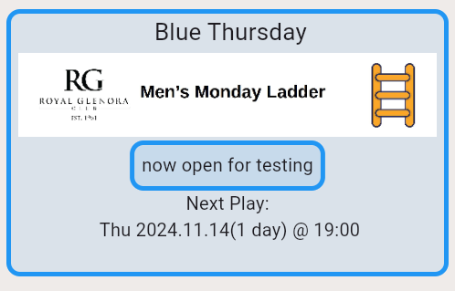

The top line is the name of the ladder as set by your administrator. e.g. “Blue Thursday”
The second line is an image chosen by your administrator.
The third line is a message from your administrator that is often used to describe special features about this ladder.
The fourth line is always “Next Play:”
The fifth line is the date and time of the next scheduled date of play. It gives the day of week, the 4 digit year, 2 digit month and 2 digit day of month. Then it gives how many days away it is and after the @ it shows the time that play starts. You should arrive ahead of that time.
The sixth line (optional) is a message from your administrator specifically about this day of play.

